Work Stream 4 workshop

15th of March 2018

Minutes of the workshop

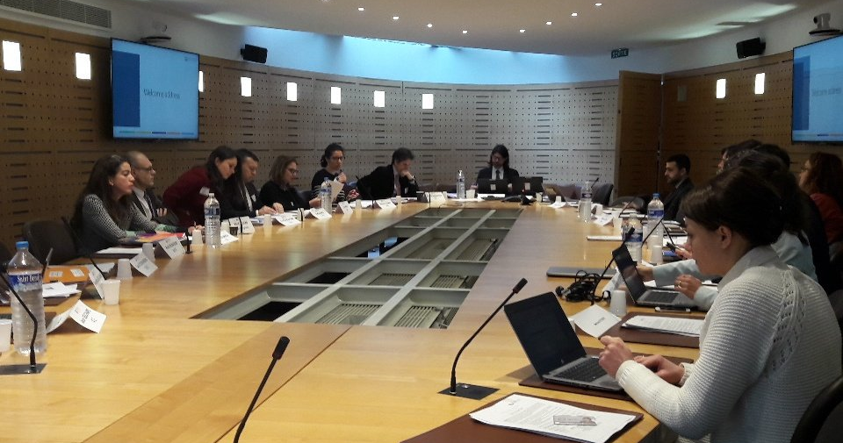

Participants:
Workshop participants representing the supporting institutions:
Agence Française de Développement (AFD) | Alexis Bonnel, Mariana Deheza, Damien Navizet, Audrey Rojkoff, Charlotte Cristofari, Bertrand Reysset
BMCE Bank of Africa | Amal Benaissa
Banque Ouest Africaine de Développement (BOAD) | Yacoubou Bio-Sawe
Caisse des Dépôts (CDC) | Tatyana Vassilevskaya
Cassa Depositi e Prestiti (CDP) | Marco Boffo
Caisse des Dépôts et Gestion du Maroc (CDG) | Laila Mikou
Council of Europe Development Bank (CED) | Anton Spierenberg
Crédit Agricole | Eric Cochard
Development Bank of Southern Africa | Nomsa Zondi
European Investment Bank (EIB) | Adrien de Bassompierre
HSBC | Deborah Kuszner
Inter-American Development Bank (IDB) | Juliana Almeida
JICA | Shizuka Onihi
KfW | Nicolai Tust
TSKB | Refik Akinci, Ece Coşkuntürk
Online participant: Arnesh Sharma (Yes Bank)
Participants representing the Secretariat: Ian Cochran and Alice Pauthier (I4CE)

Outcomes of the workshop
This workshop held under Chatham House rules was the first working session of the work stream. General trends identified by the survey of Supporting Institutions were presented and discussed around two working sessions:
Working Session 1: “BUILDING AND DISSEMINATING CLIMATE STRATEGIES"
How to build and gain institutional traction for climate strategies?

Working Session 2: “CLIMATE STRATEGIES AT THE OPERATIONAL LEVEL"
How can climate teams support the entire project, lending and investment cycles and decision making? What role for training, assistance and support – paired with assessment, review and oversight?

Following this initial discussions, Supporting Institutions presented their expectations for this Work Stream. Participants highlighted both a number of issues that need to be prioritized and ‘modalities’ to review the Work Stream’s workplan.

Next steps:
- April 2018:
  - Definition of an overarching 2018 workplan for the Initiative
  - Proposition of an updated workplan by the Work Stream co-leads
- May 2018 onwards:
  - Start of the Work Stream activities

Record of decisions and discussions
Welcome words form the work stream co-leads
Arnesh Sharma (Yes Bank) and Adrien de Bassompierre (BEI) welcomed participants for this first workshop of the Work Stream 4. They launched a “tour de table” asking all participants to introduce themselves and present why they are interested in following this work stream.
They highlighted that this work stream aims to deal with overarching issues.
Introduction session by the Secretariat
Ian Cochran (Secretariat) presented the report “Building Blocks of Mainstreaming” produced by I4CE in 2017 with support from the AFD and IDB. The report identifies and assesses three areas of ‘mainstreaming’:
- Upstream “Governance & Policy”
  - Overarching objectives, targets and goals
  - Policies, strategic documents, and action plans
  - Accountability, reporting & tracking
- Downstream “Structuring & Appraisal”
  - Decision-making and evaluation process
  - Tools and criteria
  - Knowledge base & capacity of teams
- Transversal “Support”
  - Coordination & Dialogue
  - Technical Capacity & Support
  - Incentives and provision of resources

The report identified three necessary factors to mainstream climate change in a financial institution:
- Need for a clear mandate:
  - Mandates from countries
  - Competing objectives and priorities for the institution at different levels
- Need for the issue to be seen as a priority and an opportunity (and not only a constraint) with added value:
  - Across levels of management
  - By sector-specific operational teams
  - By country-related teams
- Need for stable leadership and ‘champions’:
  - Institutionalized to ‘weather’ changes in leadership
  - Processes and dynamics to overcome institutional inertia

As part of the first phase of the work stream “Map the range of approaches to disseminate a climate strategy throughout an organization”, in late 2017 the Secretariat in collaboration with Yes Bank, the WS4 co-leader with the EIB, have conducted a survey to identify:
- What are the top three motivations for each of the interviewed financial institutions to integrate climate change inside their institution?
- How have institutions organized/reorganized themselves to integrate climate change into their decision-making processes?
- What are the principal difficulties/challenges they have faced in this process? Which approaches have been successful in their own experience?

The Secretariat started by presenting the initial results of the survey on: How climate mainstreaming started? How are climate teams organized?

Summary Presentation of Survey Results
NB: Only nine Supporting Institutions responded to the survey. Results should be taken as indicative of the variety and convergence of approaches rather than an exhaustive benchmark of current practices

Survey respondents principally started to integrate climate change as a division and/or in strategic documents in the mid-2000’s.

The following reasons for this integration were mentioned:
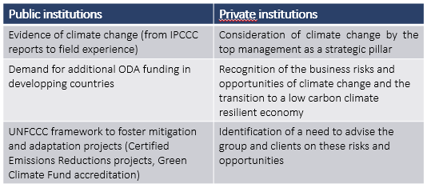
Often, it was initiated either by the top management or by the office of climate, often thanks to an internal “champion”, either the CEO or the chief sustanaibaility and climate change officer.

Other departments beyond climate change and environment were involved, such as the risks, public affairs, strategy or legal department.

Respondents indicated that the process of setting up a climate strategy lasted between 3 months to 1,5 years.

Only three development financial institutions mentionned that they had a dedicated budget for this specific task. Only 4 public institutions associated consultants to the process and mostly for technical studies.
Respondents highlighted the following 'quick wins' or the event/action that pushed their institutions to move forward on mainstreaming climate change internally:
- The role, responsibility and mandate of development banks to contribute to sustainability of the region
- Result Based Finance is the new paradigm for development banks and international finance
- Identifying opportunities in the current project pipeline to implement climate action and the better/improved tracking and tagging of climate projects.
- COP21
- Externally the Governments and private sector and internally the entire institution
- Institutional Strategy approved by the board to mainstream climate change

Respondents mentioned that climates team(s) are organised as follow:

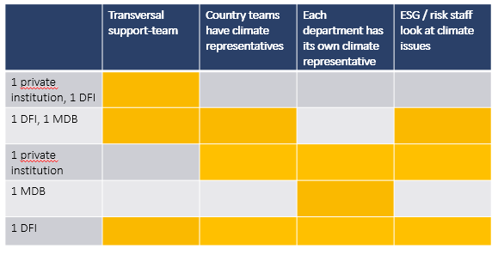

These teams report to the:
- Executive Vice-President
- Executive Director for operations
- Corporate Secretary

There are connections in general with higher levels of management for the reporting, even though connection with decision making varries widely:
- The team has a seat in internal committees as part of the Risk/ESG framework
- The Head of Environment/Climate change participates in the approvals committee
- The team is part of the decision committees of some internal climate-related trust funds
- The team has no seat/no vote in specific decision committees

All respondents indicated that they are consulted for diverse work plans, as climate change is a transversal issue.

The mandate of these teams also ranges from strategy to operations:
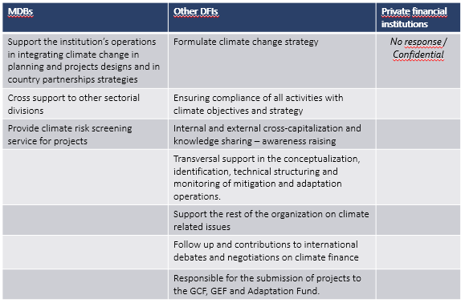

Discussion

The discussion highlighted that there is no one size fits all strategies. The successful strategy varies from one institution to another, but also between the different branches and activities of a financial institition, between its business lines and inside its business lines.

Supporting Institutions noted that they have set up different tools (minimum standards for projects, specific criteria, indicators) and approaches (decentralisation/centralisation).

Workshop participants agreed that the human factor was a major aspect to take into account in the implementation of a climate strategy. Two private institutions presented that to support and facilitate the integration of climate change, they set up internal “culture programmes” or “training programmes” for employees at different stages inside the institution. This process can help teams to recognize climate change as an issue, begin to see how to address it in their remit, and move towards concrete actions. These Supporting Institutions have agreed to provide case studies on these programs.

It was noted that the implementation of the climate strategy has to be dealt with differently in every department. Conflicts with other key policies that need to be fulfilled can appear and some institutions reported that climate mainstreaming is sometimes considered a time consuming burden. In the case of DFIs, one indicated that it has been useful to identify focal points across opperational divisions and services and then providing support to help screen projects and investments as well as provide expertise on how to improve the climate performance. Opperational teams will need to see that climate change can be addressed without negative impacts on project timeline and deadlines, nor the project budget.

One institution suggested two different approach to address creating cross-department mandates and buy in:
- Using the Nationnally Determined Contributions to indicate to public actors the objectives set by governements in terms of climate change
- Demonstrate the opportunities of financing low carbon climate resilient projects by presenting the different climate funds for example (MDBs climate funds, Green Climate Fund, Global Environmental Facility, etc.)

Workshop participants also mentioned the need to go upstream and to influence country strategies at the very beginning.

Working Session 1: “BUILDING AND DISSEMINATING CLIMATE STRATEGIES"
The Secretariat introduced the first working session by a presentation of the main results of the survey on the question: what type of objectives have financial institutions set?
Summary of Survey Results
Respondents reported the following goals and priorities set up internally:
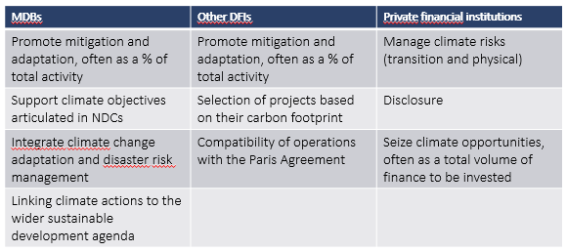
Some institutions indicated that these objectives are disaggregated by:
- Department
- Region of activity
- Sector
- Technology
Part of respondents mentioned that they referred internally to the MDBs-IDFC (International Development Finance Club) methodology for the definition of adaptation and mitigation finance; others indicated that they refer to a broader definition of sustainable finance and measure the carbon footprint of projects for example.
All respondents have or are working on Key Performance Indicators, which include:
- percentages of financial commitments with climate co-benefits
- percentage of projects integrating climate change
- reduction of the carbon footprint
- number of trained personnel
Respondents indicated that they track progress made towards meeting the objectives/targets/goals set by the climate change strategy by using:
- a matrix of all CSR challenges
- various indicators, through the group Results Management Framework and various mechanisms and technical assistance to move activities towards reaching the target
- percentages of projects with co-benefits; percentages of projects having been carbon-foot printed; effective selectivity of investments financed according to their emissions level
- Common MDBs/IDFC methodology
- KPIs
All answered that the climate change/environment unit was in charge of tracking the progress made, and it is reported to the hierarchy via :
- Annual reports of the climate activity
- 3 meetings per year of the climate committee chaired by CEO, which can also convene for specific requests.
- the climate finance target is monitored regularly and reported to management at regular intervals at the management committee meetings, which are chaired by the president.
- report of green finance (approvals/year of green operations) is being tracked every semester, with a view to increase this frequency to every quarter
The following formal/informal incentives were set up to accelerate the implementation process:
- Climate objectives feature in Senior Management Scorecards
- The societal performance measured by an index accounts for one third in the long-term variable compensation plan for Senior Executives
- The formal public commitment (in billions) made is the strongest incentive in increasing collaborative efforts within the institution
- No formal incentives, apart from indirect indicator used for collective annual premium.

Presentation of the Example of the AFD Climate Strategy
Damien Navizet (AFD) introduced the discussion session by presenting the AFD’s experience.
The adoption of the first Climate Strategy of the AFD in 2005 was driven by the vision of the CEO Jean Michel Severino, who played the role of “champion” and introduced the idea that climate change is a global issue in 2001. Climate change was considered as a great opportunity to expand the mandate of the AFD.
This first strategy enabled the institution to develop mitigation and adaptation activities and to develop a track-record, which lead to the adoption of a first main target for the whole institution in 2012: 50% of finance with climate co benefits.
Three years later, COP21 was perceived as an opportunity and the AFD committed to 5 bn EUR of climate finance per year by 2020.
In November 2017, the AFD adopted its 3rd Climate Strategy. The entire strategy can be summarized by the idea that AFD group is trying to comply with the 3rd objective of Paris Agreement of redirecting all financial flows and contributing to finance the transition to a low carbon climate resilient economy.
The most striking feature is that it set the objective to be “100% compatible” with the Paris Agreement. The target of 50% of climate finance (mitigation/adaptation) has been kept, but the AFD is trying to mainstream climate change in everything they do, not just half of it.
Damien Navizet noted that this goal was possible only due to a very specific context.
Compared with the first strategy, other major changes can be highlighted:
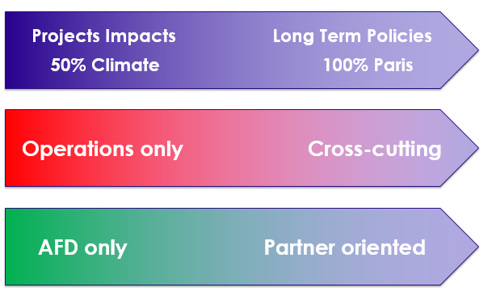
Source: AFD presentation
It started with operations (project managers building methods to count CO2 emissions) and it is now a cross cutting strategy and research, risk, treasury and Proparco teams became active on climate change.
The AFD also considers important to contribute to the public debate and aims to be more partners-oriented, with partners on the ground or through the International development Finance Club (IDFC) of the Climate Action in Financial Institutions Initiative.
Damien Navizet presented the following key drivers they identified for mainstreaming the strategy:
  - Sustained leadership vision
  - Specific objectives (volume climate finance, CO2 objectives, (carbon pricing))
  - International climate agenda
  - Risks and opportunities (opportunities appeared before the risks although risks is becoming one of the major drivers)
  - A team, which includes the climate unit but also referees across the institution. Damien Navizet noted that a climate team ensures consistency at large but should be going out of business if it is successful!
  - Time and expertise.
Damien Navizet mentioned that climate mainstreaming is never over because of new issues raising, and that we cannot mainstream overnight.
Discussion
Workshop participants presented their experience in building and disseminating climate strategies and their lessons learnt, which can be summarized as such:
What difficulties they have faced
- Have operational teams appropriate the strategy
- Recognize time that it will take and that there will be pushback due to deadlines.
- Need to identify and access additional resources (time, HR, funds) to conduct climate-related assessments and analysis.
- Ensuring targets are met at a project level
- Ensure climate team is not viewed only as the ‘police’ or ‘judge’
- Competing priorities
What workshop participants have used to overcome challenges:
- A high-level champion involved in some type of steering committee or accountability mechanism
- Political mandate and dynamic created by the international process such as COP21 or COP22
- Collaboration between development banks and private financial institutions, leading to transfer to standards and requirements to be met to be eligible for certain funding (GCF, donor support, etc.)
- Start with low hanging fruit and exclude the most difficult and controversial areas from the first round of targets and objectives.
- Joining international initiatives to give high-level visibility
- Development of internal capacity building programs
- Use of external evaluation of climate issues so that climate team will be seen as part of the project team, not as a judge.
- Internal incentives for operational teams to integrate climate change (bonuses, internal ‘green supporting factors’, etc.)
- Access to additional resources through international climate funds, GEF, GCF
- Embed climate-related issues and considerations into the formal IT and management systems

Workshop participants mentioned that the direction to which the climate team is associated to, can make a great difference and be either positive or negative in different aspects.

Working Session 2: “CLIMATE STRATEGIES AT THE OPERATIONAL LEVEL"
Ian Cochran (Secretariat) introduced the second session by presenting the results of the survey on the two following questions: How do climate teams support operations? What challenges for climate teams?
Summary of Survey Results
Respondents of the survey indicated the following role of the transversal team in the project approval process:
- Support and compliance at all stages of the project cycle
- Environmental and social risk assessment for every operations considered, at the beginning of the project cycle.
- Review process of projects in an early and then in a more advanced stage
The transversal team assist operational teams:
- Through the environmental and social risk assessment committee
- Advise on formulating projects by operational teams
- By providing technical support to link the project to climate change considerations in the form of comments to be included in the projects and support during the design and negotiation with the government
- Key role in all 5 steps of a project cycle: origination, evaluation, approval, formalization and administration
Three institutions indicated that the transversal team mainly have a support role.
One indicated that it finances technical cooperation and works to bring alternative international financing to the operations (e.g. responsible to structure funding proposals presented to the GCF, GEF, Adaptation Fund)
Another mentioned that focal points in each department are responsible for the development of projects in their own department.
Respondents mentioned the following advantages and disadvantages of these arrangements:
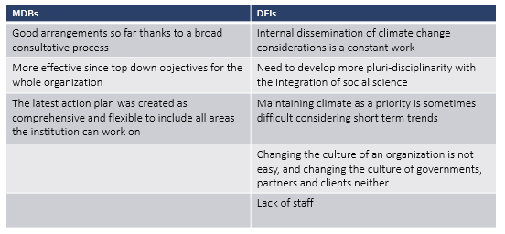
They indicated the following missing aspects to be improved:
- Long term strategic foresight
- Resources constraints limit the development of the climate portfolio
- More active role in projects
Respondents indicated the following next steps to consolidate or further disseminate the climate strategy internally:
- Preparation of a new strategy, with the hope to re-generate enthusiasm
- Preparation of a big event with country offices to show that climate change operations are possible
- Training to explain climate finance tracking methodology
- Strengthen the capacity of the focal points in each division

Presentation EIB Case Study
Monica Scatasta then presented EIB’s experience in a brief case study presentation to launch the discussion.
She indicated that in 2017, EIB financed 19.6 bn EUR (28% of all financing) for climate action, including 800 million for adaptation.
EIB’s Climate Action targets (Pre-COP21) are the following:
- Overall (worldwide) lending for Climate Action of >25% every year;
- Increase its lending for Climate Action in developing countries to 35% by 2020
- USD 100 billion for Climate Action during the 2016-2020 period
EIB supports the Paris Agreement by:
  - Supporting EU climate policies and NDCs
  - Setting ambitious volume targets
  - Rigorous tracking
  - Managing climate risk
  - Using a shadow price of carbon
  - Mainstreaming climate consideration into all policies, practices.
In 2015, EIB adopted a climate strategy towards 2020, which sets the following objectives:
- Reinforcing the impact of EIB climate financing
- Building resilience
- Further mainstreaming climate change considerations across EIB standards, methods
This strategy is a living document that needs to be updated as time goes. They are currently doing a mid-term review, taking stock of the latest developments.
This strategy was translated into Actions Plans (2017-2020) for the implementation of the strategy.
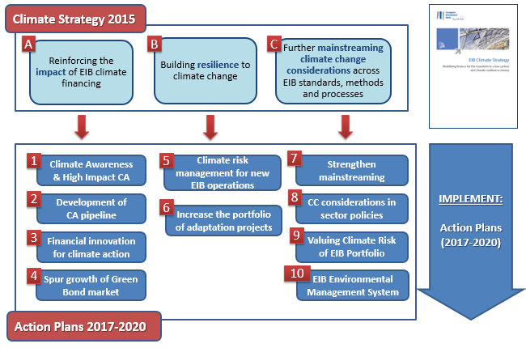
Source: EIB Presentation
Each of the objectives of the strategy were translated into an Action Plan, defined with operational colleagues, which aims to provide a planning tool for different services of the EIB, with activities and outputs.
Monica Scatasta mentioned the importance of bringing people together and developping differentiated guidance materials for each department.
The EIB also set up a task force for valuing the risks in the portfolios, bringing in risk management colleagues. Output will be integrated into the larger risk framework of the bank.
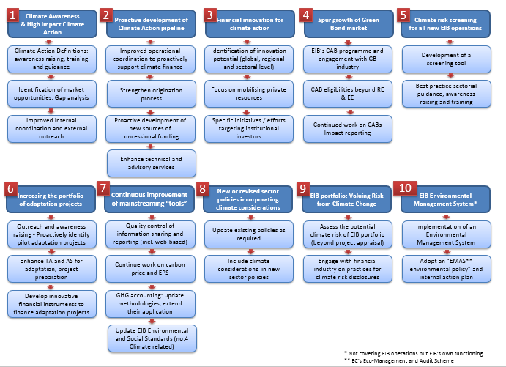
Source: EIB Presentation
The EIB set up a steering committee at the director level, which ensures the buy in and push for the dissemination of elements of discussion.
Discussion
The Workshop Participants highlighted in the discussion many of the difficulties already discussed briefly during Session 1 in supporting operational teams. There was a general consensus that a key step is ensuring that different departments see how climate change links directly to their activities and principal concerns (project success, default risk, etc.). It was stressed that engaging directly with teams and presenting the climate challenge from their perspective is essential. Some institutions also mentioned the need to develop trainings at different levels: for the COMEX, for managers and for operational teams.
The process of supporting operational teams requires that, from experience, the climate strategy evolves over time and the need to embed flexibility in the whole strategy as the learning curve can be steep.
One institutions indicated that setting up geographical targets for climate could facilitate the work with country and project teams to find opportunities to finance more climate projects.
Having a transversal team involved in the design of projects and providing grants to support climate consideration at the design stage were also mentioned as two important ways to leverage climate projects finance.

Workshop Conclusion and Next Steps
The workshop ended with a final “tour de table” of expectations for this work stream.
Participants highlighted that while all topics were interesting, that there is a need to prioritize. During the session, interest was noted on:
- How to incentive operational teams to contribute and integrate the climate strategy and targets
- how to manage different expectations from governments to civil society
- what incentives to implement to facilitate the spreading of the climate strategy
- how to get clients motivated to provide data to assess climate issues
- how to help high carbon companies change their business model
- approaches for SMEs
- moving towards industry standards for all financial institutions so that climate unfriendly projects/companies will not be financed
- the Green Climate Fund processes
- Linking with parallel discussions on other UN Conventions on Desertification and Biodiversity
Additionally, the ‘modalities’ of advance the workstream’s workplan were discussed. A number of options were identified, including:
- A survey of Supporting Institutions to map the main dilemmas institutions are currently facing;
- Case studies of specific practices (scorecards, internal training modules, acculturation activities, organizational approaches, assessment and identification techniques).
- Organize in person or teleconference / videoconference discussion sessions. It was stressed that an effective option may be to structure discussions around concrete cases and examples presented by Supporting Institutions to identify real-world difficulties and discuss means of moving forward.
The need to develop capacity-building activities on this issue was mentioned by several workshop participants.
The work stream co-leads took note of these suggestions and will organize a follow up call to present a revised action plan.

The full report is available at: https://www.i4ce.org/download/building-blocks-of-mainstreaming-of-climate-action-in-financial-institutions/
Please find the detailed presentation of results in the slidedeck of the Workshop in Annex
The slidedeck for this presentation is integrated in the general slidedeck of the workshop in Annex
The slidedeck for this presentation is integrated in the slidedeck of the workshop in Annex

