Successfully Implementing the MDB-IDFC Common Principles for Climate Finance Tracking: Experience from Supporting Institutions

Webinar held on March 25th, 2018

Summary and Partial Transcript

Participants:
- Supporting Institutions:
  - Charlotte-Fleur Cristofari, Myriam Dahman Saidi (AFD, French Development Agency)
  - Rita Gabriella Lobo Arruda, Marcos Ferran (BNDES, Banco Nacional de Desenvolvimento Econômico e Social)
  - Soumia Bahi, Amal Benaissa, Soraya Sebti, Nour Zenined (BMCE Bank of Africa)
  - Miguel Mendez (BCIE/CABEI, Central American Bank for Economic Integration)
  - Pedro Andersen (BICE, Banco de Inversión y Comercio Exterior)
  - Martha Castillo, Ubaldo Elizondo, Marie Le Gac, Alejandro Miranda, Camilo Rojas, Edgar Salinas, Nara Vargas (CAF, Banco de Desarrollo de América Latina)
  - Sara De Pablos (CEB, Council of Europe Development Bank)
  - Julie Clarke, Nomsa Zondi (DBSA, Development Bank of Southern Africa)
  - Peter Anderson, Esther Badiola (EIB, European Investment Bank)
  - Mikkel Kallesoe (FMO)
  - Luna Montozzi, Estibalitz Morras (International Fund for Agricultural Development - IFAD)
  - Susana Cardenas, Vanessa Callau Ferreira, Claudia Hernandez, Rossemary Yurivilca (IDBG, Inter-American Development Bank)
  - Natou Bamba-Colon (Proparco)
  - Yasser Ibrahim, Natalie Marie Weigum, (World Bank)

- Secretariat: Ian Cochran, Marion Fetet (I4CE, Institute for Climate Economics)

Agenda
- Introduction
- Mitigation
  - Brief presentation of MDBs-IDFC Common Principles for Climate Change Mitigation Tracking – CAF/IDB
  - Case studies: How is mitigation integrated into procedures and operations of CAF and IDB
  - Questions from participants
- Adaptation
  - Presentation of MDBs-IDFC Common Principles for Climate Change Adaptation Tracking – AFD
  - Case studies: How is adaptation integrated into procedures and operations of the AFD
  - Questions from participants
- Discussion and wrap-up

Record of discussions

Introduction
The call started by welcome remarks from the Secretariat.
Susana Cardenas, Senior specialist in the Climate Change Division of the Inter-American Development Bank started the presentation of the MDBs-IDFC Common Principles for Climate Change Mitigation Tracking on behalf of the MDB Working Group on Climate Finance Tracking.
During COP15 in 2009 in Copenhagen, a commitment was made to increase climate finance but there was no agreement on what climate finance meant. The group of Multilateral Development Banks, which was used to working together on many other subjects came up with:
- A definition of climate finance in 2011: development finance with clear mitigation and adaptation purposes and benefits.
- Two distinct methodologies for mitigation and adaptation.

In 2015, as a voluntary joint initiative, the members of the Multilateral Development Banks (MDBs) Climate Finance Tracking Working Group and the International Development Finance Club (IDFC) Climate Finance Working Group agreed on a set of Common Principles for Climate Finance Tracking:
- MDBs-IDFC Common Principles for Climate Change Mitigation Tracking
- MDBs-IDFC Common Principles for Climate Change Adaptation Tracking

For both mitigation and adaptation climate finance tracking, attributes are the following:
  - Additionality
  - Conservativeness
  - Granularity
  - Scope: project-bound
  - Point of assessment: at approval

The MDBs’ 8th Joint Annual Report will be released early June.

Mitigation

Presentation of MDBs-IDFC Common Principles for Climate Change Mitigation Tracking
Susana Cardenas presented the common methodology to track climate change mitigation finance. It includes all attributes above-mentioned and applies a positive list of eligible activities that are deemed to support low-emissions development pathways, based on predictive value of financed activities.
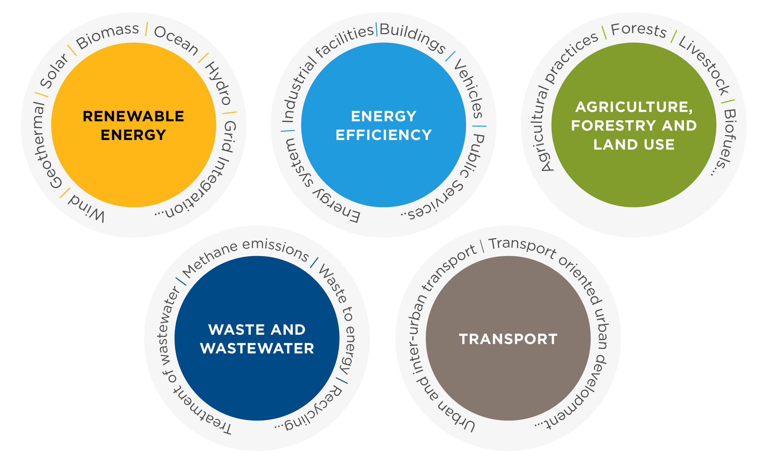
Institutions do not always have to demonstrate net emissions reductions, but they have to indicate the specific project’s elements targeting emissions reductions specifically.
The methodology identifies categories and sub-categories of eligible activities:
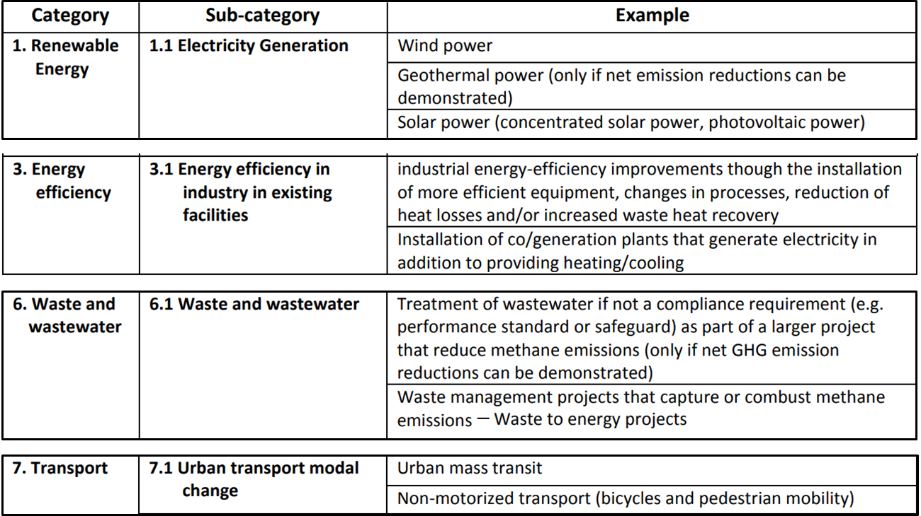
Edgar Salinas (CAF) highlighted a few points:
- This tracking exercise is made in the context of countries’ pledges as part of climate negotiations.
- The objective is to report an “intention”: it does not include an assessment of the actual impact of financial flows. It is an ex ante estimation of potential emissions reductions.
- As many operations of development finance institutions are complex, one key challenge is the identification of the specific component compliant with the common principles and report on the share of financial resources of that components, as opposed to reporting the whole activity finances.

Case study: Institutional Arrangements to mainstream GHG Mitigation – CAF (Development Bank of Latin America)
Edgar Salinas presented the implementation of these principles, based on CAF experience.
First step: identify who inside the institution and across the different business units is going to be an “ally” and provide information for the reporting.
In CAF case, the Climate Change unit oversees the reporting exercise, but it could not undertake this exercise without the assistance from the risk assessment unit, which is led by the Risk Analysis Vice-presidency in charge of both financial risks and social and environmental risks. The risk assessment unit provides the first categorization of CAF projects.
Second step: write internal procedures.
In CAF case, one of the major rulebook governing credit operations is the Manual for Credit Operations. This manual indicates that operations have to undertake and perform due diligence (a financial due diligence and environmental and social risk analysis).
In addition, CAF developed a procedure for environmental and social assessment and monitoring of operations to support the risk analysis department in categorizing operations in line with the Common principles for Climate Finance Tracking.
Challenges:
CAF identified two major risks and challenges:
- different interpretations among the different teams (risk, climate, etc.)
- not allocating the correct share of the financial resource dedicated to the climate mitigation component of projects.
To avoid these risks, CAF recently set up periodic calibration exercise, during which teams bring case studies for discussion and collective analysis. Documented conclusions are kept for reference.
CAF also uses a carbon footprint tool to calculate emission reductions and the carbon footprint of projects.
Edgar highlighted the importance for the process not to be pushed by the climate division itself and to bring more people on board. To this end, CAF developed an online training.
At CAF, climate mainstreaming relies on:
- close collaboration with business units
- regular exchange between Climate Change and E&S Risks Units
- exchange with departments involved with mapping and reporting
To raise awareness of clients beyond the institution itself, CAF also developed a cities footprint program.

Case study: How is mitigation integrated into procedures and operations at IDB
Susana Cardenas presented IDB’s experience
IDB’s organization
In 2016, IDB established a new department, which brings together all climate change and sustainability practice but also has links to the rest of the operational programs of the bank.
The climate change unit – a team of about 50 people – is in charge of mobilizing climate finance, advising on operations, generating knowledge on climate change, tracking climate finance. This department is part of the climate change and sustainable development sector Vice-Presidency.
Both IDB and IDB Invest, the institution in charge of all the private sector activities, integrated climate change and sustainability as a cross-cutting issue.
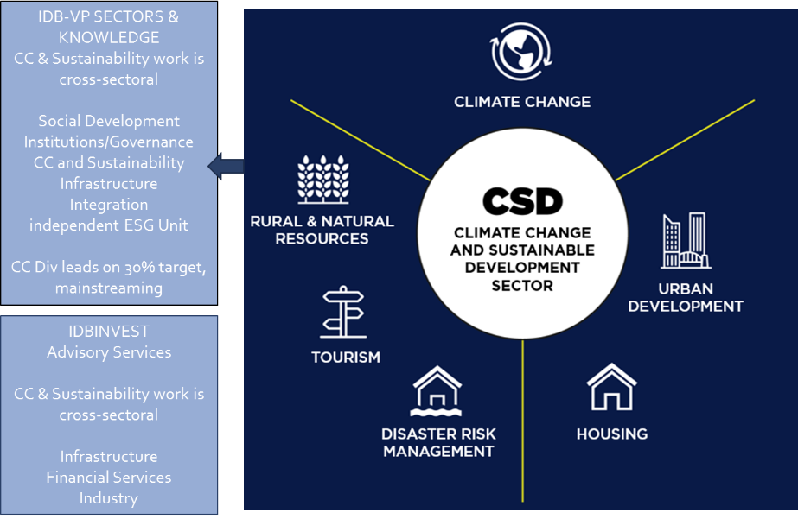
IDB’s procedures
Susanna Cardenas then presented how climate change is integrated into the project cycle:
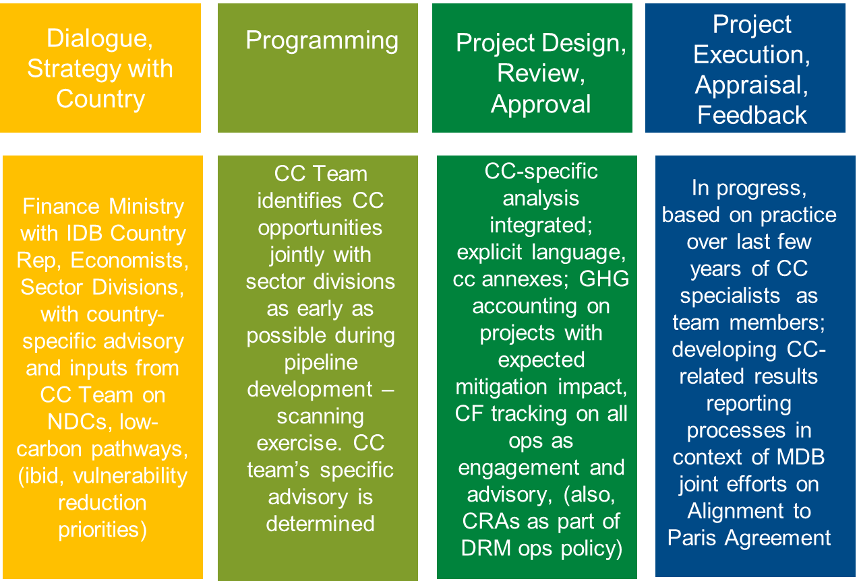

Questions
Charlotte Cristofari (AFD) asked if institutions could share their experience in accounting for GHG emissions avoided by energy efficiency and overcoming challenges.
Edgar Salinas (CAF) indicated that for GHG accounting, there is a need to measure emissions reductions per unit of production and the chosen baseline needs to be a bankable project.

Adaptation

Presentation of MDBs-IDFC Common Principles for Climate Change Adaptation Tracking
Bertrand Reysset, lead adaptation specialist of the French Development Agency (AFD) started with a brief presentation of the difference between mitigation and adaptation.
- Mitigation is about assessing at the impact of the project on the environment through GHG emissions.
- Adaptation is about assessing the impact of climate on a project/ the communities.
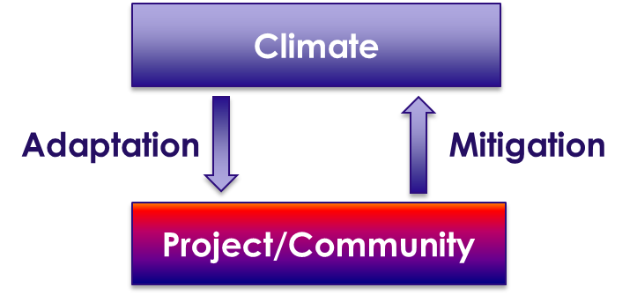
For development banks, adaptation usually means reducing vulnerabilities (or harnessing opportunities) to current AND future climate.
Bertrand Reysset highlighted that as adaptation is highly context specific, a positive list cannot be used to categorise adaptation activities.
In 2015, MDBs and IDFC adopted Common principles to track adaptation finance in a more comparable way. The approach presented in the principles is « process-based » and « project-documentation-based ».
It is a 3 steps approach:
- inform the context of climate vulnerability of the project,
- state in the project documentation the intent to address these specific vulnerabilities,
- explain the activities that will specifically address the identified risks = adaptation activities
Then the aggregated costs of adaptation activities represent the adaptation finance of the project (0-100%). When adaptation activities are not exclusively geared towards climate adaptation, they should be under reported.
This approach is considered as a good practice according to OECD-DAC, which recommends to apply it in the RIO markers’ approach.

Case study: How is adaptation integrated into procedures and operations at the AFD?
Firstly, Bertrand Reysset highlighted that climate vulnerability screening is mandatory for AFD projects since 2015. This systematic and mandatory procedure enables to identify adaptation options more easily.
Secondly, project document templates have a specific section on how the project is responding to the 3 steps of the Adaptation Common Principles.
In addition, the climate division supports project teams in identifying adaptation gaps and actions.
The climate division is in charge of tracking adaptation finance and to avoid any risks due to conflict of interests tracking is audited on an annual basis.
Bertrand Reysset finally highlighted that another aspect and probably the most important is AFD’s commitment to reach a € 1,5bn corporate target of adaptation finance per year by 2020. This is a great incentive for the teams.
Bertrand concluded his presentation by sharing lessons learned from AFD:
Tracking adaptation needs:
- Early integration of the climate risk concept in the project cycle (including ToRs if relevant depending on the business model)
- Time/trained staff. Adaptation is not complicated, but as it is new, there is a need to build capacity.
For in-depth lessons learned from IDFC members and the MDBs, please see this publication.

Discussion
- Ian Cochran (I4CE) asked Supporting Institutions what moving towards a more impact-focused from a more volume-focused exercise might mean and involve?
Bertrand Reysset (AFD) agreed that as of now the approach was looking at volumes, in line with the Cancun commitment, but there are concerns that this approach is not tracking impact. Discussions are in progress between MDBs and IDFC members but the groups identified a number of challenges in trying to report impact.
- Ian Cochran (I4CE) asked Supporting Institutions what would be their recommendations for an institution starting to roll out tracking?
Edgar Salinas (CAF) mentioned that tracking first needs the buy-in from the top management. Then institutions can keep things simple: look at the portfolio in terms of sectors but also in terms of type of services you provide and test the procedures in specific segments. Looking at projects is easier than credit lines for example.
Bertrand Reysset (AFD) highlighted that there was a need to increase the attention institutions pay to adaptation finance.
- Nomsa Zondi (DBSA) indicated a need for discussions and exchanges on adaptation methodologies.
Bertrand Reysset (AFD) agreed that there was a need for discussions.

Materials
Case studies related to this webinar are available on the Climate Mainstreaming Practices Database. Among others:
- MDBs and IDFC establish Common Principles for Climate Finance Tracking
- MDBs Harmonize Approaches for Tracking in Order to Improve Disclosure of Important Climate Data
- The IDFC Publicly Reports Green and Climate Finance Data

All webinars recordings are available for Supporting Institutions at this link: https://www.youtube.com/playlist?list=PLtZv2BqnaNF3IibxesTy5MocqRrxNH2cR
Please do not share this link beyond your institution.

