Managing Uncertainty

Webinar held on February 24th, 2020

Summary and Partial Transcript

Participants:
- Supporting Institutions:
  - Musole Mwila Musumali (AfDB, African Development Bank)
  - Alexis Bonnel, Mariana Deheza, Camille Laurens-Villain, Gaelle Le Cleach (AFD, French Development Agency)
  - Ubaldo Elizondo (CAF, Development Bank of Latin America)
  - Esther Badiola, Mihaela Bujoi, Daniel Farchy, Georges Gloukoviezoff, Heloise Gornall-Thode, Giuseppe Lombardi, Wouter Meindertsma, Beatrix Thaler, Victor Tonucci, Carsten Wachholz (EIB, European Investment Bank),
  - Davor Kunc, Paula Ruiz (European Investment Fund)
  - Marco Buttazzoni, Maricarmen Esquivel, Claudia Hernandez, Scarleth Nunez, Jose-Manuel Sandoval (IDB, Inter-American Development Bank)
  - Aditi Maheshwari, Ayesha Malik (IFC, International Finance Club)
  - Ahmed Al Qabany, Olatunji Yusuf (IsDB, Islamic Development Bank)
  - Benoit Blanc (Stoa Infra & Energy)
  - Arnesh Sharma (Yes Bank)
- Secretariat: Ian Cochran, Alice Pauthier (I4CE, Institute for Climate Economics)
- Invited experts: Vivian Depoues, Anuschka Hilke, Romain Hubert (I4CE, Institute for Climate Economics)

Webinar Agenda
- Presentation of the report published in 2019 by I4CE – Institute for Climate Economics Towards an alternative approach in finance to climate risks: Taking uncertainties fully into account
  - Brief introduction: Uncertainty in climate risk management - Vincent Bouchet (Groupe Caisse des Dépôts & Chaire Energie et Prospérité)
  - Presentation of decision-support tools used in other sectors to manage uncertainty - Vivian Dépoues (I4CE)
  - Presentation of authors’ suggestions to adapt the above-mentioned tools to finance - Vincent Bouchet (Groupe Caisse des Dépôts & Chaire Energie et Prospérité)
- Discussants: Alexis Bonnel and Camille Laurens-Villain (AFD)
- Discussion

Record of Discussions

Presentation of the report
The 2019 report Towards an alternative approach in finance to climate risks: Taking uncertainties fully into account written by Vivian Dépoues (I4CE), Vincent Bouchet (Groupe Caisse des Dépôts & Chaire Energie et Prospérité), Michel Cardona (I4CE) and Morgane Nicol (I4CE) is intended to serve as a basis for exchange on the management of uncertainty between banking sector risk management practitioners and the regulator, as well as operatives and researchers who have already applied exploratory approaches in other areas.
Vincent Bouchet (Caisse des Dépôts - France) started the presentation by highlighting the three sources of radical uncertainties around climate change:
- The natural variability of the climate, a non-reducible uncertainty.
- Scientific uncertainties: models are simplified representations of reality.
- Socio-economic uncertainties: although the energy transition that the global economy will follow is already underway, it is very difficult to predict.
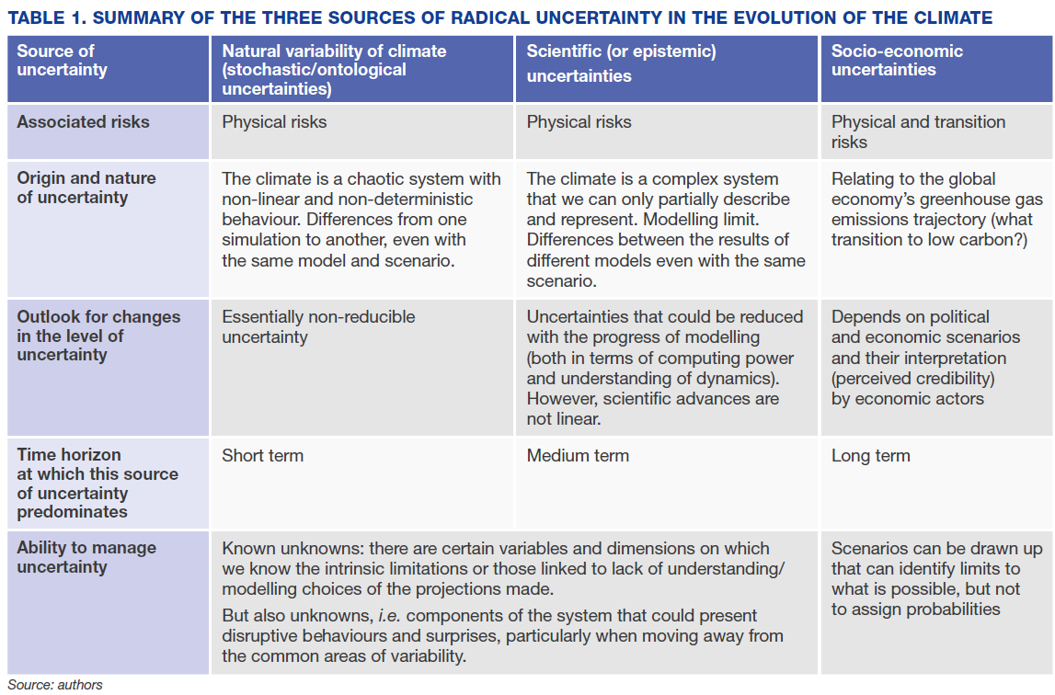
Source: I4CE (2019)
Vincent Bouchet (Caisse des Dépôts - France) then highlighted why traditional financial risk management approaches may be inadequate.
Risk management in the banking sector has several characteristics. It was initially integrated only into lending or investment decisions (both in terms of tools, processes and actors involved), but in the 1990s it was structured using the three lines of “defence model”:
- The first line of defence corresponds to the front office functions. Whether granting a loan or investing in a financial security, the banker or the manager incorporates a risk component in his or her decisions, which depends in particular on the institution’s risk appetite and the rules defined by the second line of defence;
- The second line of defence corresponds to the specific functions of the risk department, which is responsible for monitoring the risks taken by the front office and ensuring compliance with the institution’s own risk appetite framework and regulatory requirements;
- Lastly, the third line of defence corresponds to internal audit, which is responsible for controlling risk management processes.
In addition to banks, the regulator also looks at financial risks. Dealing with climate-related uncertainties may require changes in financial institutions internal processes but also changes in the micro and macro-prudential regulation.
Figure: Three lines of defence model
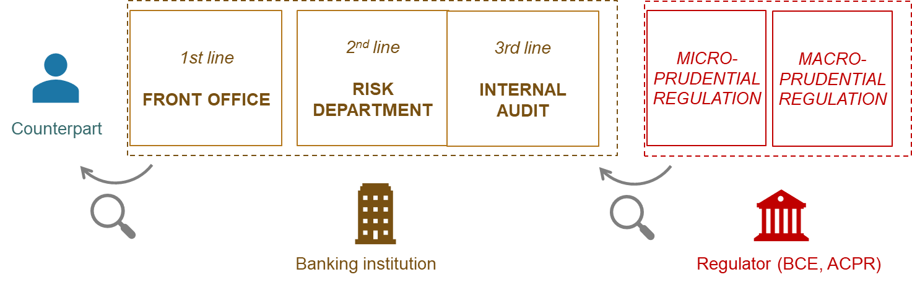
Source: I4CE (2019)
When thinking about the integration of climate-related uncertainties, it can be important to map internal decision processes within a financial institution (see table below):
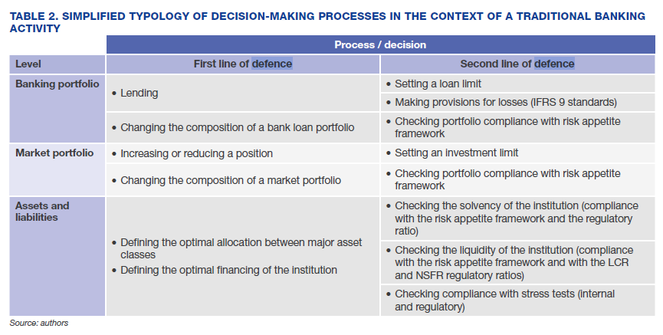
Source: I4CE (2019)
As mentioned above, these processes are not limited to the risk department.
From scenario analysis to scalable and robust decisions
Traditional approaches to risk management in the banking sector are characterised by an increased use of quantitative indicators, based on historical data and on assumptions of normal distributions. One of the most used indicator is the value at risk.
However, from a regulation perspective, recent crises have shown the limits of these indicators, and have led to develop the use of scenarios analysis. Scenarios can represent one way of addressing uncertainty, understood as something we cannot associate probabilities to, even though scenarios are today often associated with probabilities.
However, several obstacles have emerged (taken from I4CE 2019):
- Incompatible time horizons The horizons considered in current analyses are often too short compared to those of climate scenarios, which tend to be ignored. Furthermore, standard financial analysis tends to reduce the weight of the future in the decision by using high discount rates. For example, credit ratings can be determined on the basis of an analysis of the current economic cycle, the time horizon of which is estimated to be between three and five years. Regulations also require that they be reviewed every year, which does not encourage long-term thinking. And even if we consider that these ratings say something about the probabilities of default over the entire life of the loans granted, it is once again only on the basis of claims tables defined according to the analysis of the past.
- Granularity and contextualisation of input data Existing risk assessment tools are built to consider certain predetermined variables with a certain granularity of the information presented in a certain form. However, the relationship between climate and these variables is not always direct and often complex to represent. For example, the physical risk to an activity depends not only on its exposure but also on its vulnerability and its capacity for resilience and adaptability. The ability to respond to a disruption can thus be greater or lesser from one company to another and for the same asset. Moreover, the accuracy of the information available is far from being homogeneous from one location to another, from one sector to another, or from one hazard to another. The data provided by climate service providers are very heterogeneous and not immediately usable (Hubert, Evain, and Nicol 2018).
- Assigning probabilities to scenarios In general, risk is assessed by existing tools on the basis of distributions of probability of possible futures. This is how the tools were designed, in a context where historical decline made it possible to have quantified distributions of risks. However, due to the uncertainties described above, the climate change scenarios generally cannot be assigned probabilities because there are no statistics for the future. As the authors of the E.T. project also point out regarding transition risks: “To factor the risk of transition to 2°C into current valuation models, analysts should assign a probability to the results of specific scenarios in order to establish a weighted average. However, scenarios are not forecasts and scenario designers do not assign them probabilities. There are an infinite number of plausible ways to achieve the objective of limiting climate change to 2°C. It is therefore very difficult to integrate the results of scenario analysis into current assessment models” (Röttmer, Mintenig, and Sussams 2018; Raynaud et al. 2018).
- Representation of disruption dynamics By construction, traditional risk assessment models represent a normal functioning of the financial system, close to known areas of variability. They are not at all designed to account for non-linear consequences or possible disruptive effects that could result from structural changes to the system. However, with climate change, this possibility cannot be ruled out a priori. Given these problems encountered in the only route explored until now, and in the absence of an obligation or a challenge to the functioning of standard processes, the analyses are mainly business as usual, which means these new risk factors are not – or barely – taken into account.
Vivian Dépoues (I4CE) then highlighted that these obstacles and uncertainty cannot, however, be a pretext for inaction. It is not because the available information does not look like the information usually used that it cannot be taken into account. In the report, the authors wanted to see how non-financial sectors try to develop methodologies to take the best out of this kind of information in spite of or with this kind of radical uncertainties and draw inspiration from these other sectors even if they imply important operational challenges.
The analytical frameworks to be presented are at odds with conventional risk assessment. They consist of leaving aside the desire to model risks and the possibility of optimising choices according to a likely future (predict-then-act approaches) to explore a diversity of possible futures and assess the performance of different management options with regard to this diversity. Such approaches aim to answer the question: How to think systematically in the face of a wide range of potentially contradictory assumptions and decision parameters?
Scenario analysis is the main tool we think of for conducting this type of procedure. However, in this type of approaches the objective is not to build one, two or three scenarios and to associate probabilities to these scenarios, but to design all possible scenarios to fully represent the range of uncertainty and all possible future, including disrupting futures.
To do this in practice, an institution can use:
- Qualitative approaches, relying on consultation with stakeholders, for example through collective scenario construction approaches
- Quantitative approaches relying on digital tools such as scenario-discovery algorithms to identify from among a large number of simulations that cause the conditions of the future environment to vary, the situations in which the proposed decision proves to be at risk.
Having multiple scenarios makes it possible to assess how different strategic options could behave in a variety of future conditions and thereby decide, according to its priorities, by valuing in particular two criteria complementary to performance criteria:
- Adaptability: This first criteria aims to factor in the temporal dynamics into the management strategy by considering the reversibility of choices and their flexibility or adaptability. Various tools have been developed in this regard, including Real option analysis and Dynamic adaptation pathways.
  - Real option analysis (ROA):
  - Assessing the costs and benefits associated with each management option envisaged
  - Difficult to implement (heavy and data-intensive analysis)
  - Particularly useful for decisions involving significant capital costs and low reversibility
  - Dynamic adaptation pathways:
  - Combining adaptive management approaches and work on adaptation tipping points.
  - 5 steps process:
    - Explain the final objective and its horizon
    - Identify, among the risk factors considered, the threshold values are important to monitor
    - List all possible responses to reduce these thresholds
    - Design the sequences of possible actions that make it possible to achieve the objective initially set
    - Compare the possible sequences by taking into account the different parameters of interest: total cost of actions in the end, times when the choice must be made
Examples are available in the paper.
- Robustness: The second criteria for response in situations of uncertainty is to favour robust strategies, i.e. favouring satisfactory results in a wide range of conditions and optimal results in very specific conditions. In other words, the aim is to find among the available management options one that minimises regrets regardless of the possible futures. Approaches to identifying and qualifying these options are for example used for the dimensioning of critical infrastructures.
  - The Robust Decision Making (RDM)
The general principle is to confront each planned decision with a wide range of possible futures in order to (i) assess its robustness, and (ii) identify the types of situations (families of futures) under which the envisaged decision would be non-efficient and highlight its weak points and vulnerabilities. It does not make it possible to identify the best strategy, but to discuss the trade-offs to be made.
As a conclusion and to start framing the discussion, Vincent Bouchet (Caisse des Dépôts - France) started to address the question of how to adapt these approaches to the financial sector? This includes two types of reflections:
- How can we adapt existing decision-making process?
- How can we rethink the organization of the whole process?
The following table maps the applicability of the exploratory approaches to banking management processes:
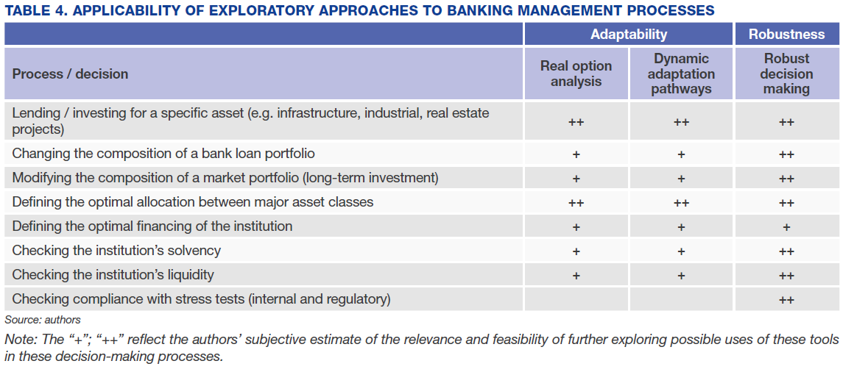
Vincent Bouchet highlighted 2 examples:
- Financing specific assets, such as infrastructure projects: The most natural use of exploratory approaches such as real option analyses, adaptation pathways or robust decision analyses could be in the case of specific investment or asset financing decisions: infrastructure, large industrial or real estate projects. The scale of such projects, their relatively small number, the long-time horizons involved and the low liquidity of these assets justify analyses specific to each asset undertaken by investors and financiers. This would make all the more sense as these projects are often very significant.
- Exploratory approaches and in particular analyses of robust decisions could also make it possible to optimise the management of portfolios whose assets are intended to be kept over the long term. In this case, the aspect of long-term retention of the assets plays an important role in the decision to use these types of approaches.

Discussants’ Interventions

Camille Laurens-Villain (AFD) reacted on two points:
- Traditional risk analysis tools do fail to take into account climate change financial risk:
She presented AFD’s experience in assessing its portfolio exposure to climate physical risk. The initial objective was to have a mapping of AFD’s main physical risks and to push the analysis on a sample of borrowers to identify the financial impact of climate hazards and take them into account in the credit rating (for more information, see AFD’s case study).

In doing this, AFD faced the obstacles identified in the presentation:
- Granularity of data: the scores collected aggregate a large amount of data and they are not associated with a probability;
- Time horizon: unable to capture disruptive events that never occurred yet.

- The alternative approaches presented are challenging to implement:
- Teams are demanding quantitative solutions. Otherwise, they can be sceptical and react saying that climate impacts are too difficult to assess. Having harmonized and easy-to-use metrics might be necessary to make sure the teams are on board and may be a first step towards a better integration of complexity and uncertainty.
- These methods are unknown in most FI and require team training.
- These methods are time-consuming.
Alexis Bonnel (AFD) indicated that this topic is an important strategic consideration for financial institutions for several reasons:
- Financial institutions through their tools and instruments link present-day institutions and individuals with future projects; and the future is full of uncertainty. So far, financial institutions have been championing risk management, but they also have been indirectly supporting “blindness” to uncertainties that cannot be translated into a risk component with a probability and an evaluation of potential damages if the risk becomes reality. As such, embracing uncertainty for a financial institution appears to be at the core of its corporate social responsibility and a lot more should be done in this area, which is only emerging these days.
- We are facing a more complex and uncertain world and the uncertain part of the future seems to be growing on a daily basis. This is putting even more pressure for financial institutions to have a better look on the integration of uncertainty in their decision-making processes.
- He also highlighted that there is an important qualitative dimension that need to be added to these approaches to embrace uncertainty. Discussions will be needed between the different stakeholders related to the social acceptance of regrets and of no-regrets, to the elaboration of scenarios. Integrating social science aspects in the development of alternative approaches will be necessary.
- He then broaden the discussion highlighting that these approaches can be adapted not on only for financial institutions’ risk management processes but also for other processes such as the development of long-term pathways, emergency situations, etc.
- He concluded by suggesting that there could be a role for the Climate Action Initiative to identify existing approaches of this type and help disseminate these approaches through a collection of case studies from different financial institutions. These case studies could focus on concrete ways to overcome internal barriers, to shift from a risk management culture, to a culture that is also accepting and embracing uncertainty, for the sake of higher quality of decision-making.

Discussion
Aditi Maheshwari (IFC, International Finance Club) indicated that IFC is currently in the process of developing their approach to undertake scenario analysis, responding to the findings of the TCFD. She agreed with Alexis Bonnel’s suggestion to share experience on that topic as it is new and as institutions are experiencing different approaches, it would be useful to identify what work and does not work. Both case studies and discussion sessions would be useful to advance on that topic.

Materials
Link to the study presented: https://www.i4ce.org/download/for-another-approach-to-climate-risk-in-finance-taking-uncertainties-fully-into-account/

All webinars recordings are available for Supporting Institutions at this link: https://www.youtube.com/playlist?list=PLtZv2BqnaNF3IibxesTy5MocqRrxNH2cR

Please do not share this link beyond your institution.

This is possible with a small number of scenarios if they are well chosen to reflect the aspects that the institution wishes to explore (for example seeking to construct the worst-case scenario, or the limit scenario that put the strategy at risk, or the scenario corresponding to an event known to be slightly worse, etc...). This is also possible with numerical tools that generate thousands of scenarios. Detection algorithms are then used among all these scenarios of interest for the analysis according to certain criteria (e.g. scenarios that defeat the option being evaluated, unpublished scenarios, families of scenarios, etc.). For more information, see the report: Towards an alternative approach in finance to climate risks: Taking uncertainties fully into account

