Managing the risks and opportunities of the low carbon transition in South Africa

Webinar held on April 22nd, 2020

Summary and Partial Transcript

Participants:
- Supporting Institutions:
  - Musole Mwila Musumali, Balgis Osman-Elasha (AfDB, African Development Bank)
  - Carl Bernadac, Laurent Bergadaa, Sandie Boyer, Mariana Deheza, Nadia Kruger-Levy, Camille Laurens-Villain, Nicholas Nhundu (AFD, French Development Agency)
  - Mohamed Hafnaoui, Laila Mikou (Groupe CDG, Caisse de dépôt et de gestion (Maroc))
  - Edgar Salinas (CAF, Development Bank of Latin America)
  - Julie Clarke, Libby Dreyer, Alter Mavunda Mbele, Bongani Msimanga, Saphira Patel, Nomsa Zondi (DBSA, Development Bank of Southern Africa)
  - Franka Klingel, Nick Plummer, Dan Storey (EBRD, European Bank for Reconstruction and Development)
  - Ahmed Al Qabany, (IsDB, Islamic Development Bank)
  - Daniel Türkis (KfW, Kreditanstalt für Wiederaufbau)
  - Natou Bamba-Colon, Alexandre Leyvastre, Helene Mace, El-Hadj-Moustapha Ibrahim Malloum, Adriana Ochoa Yepes (Proparco)
- Invited Guests: Felicity Carus, Matthew Huxham, Alejandro Navas, Joseph Henry Nkeng (CPI, Climate Policy Initiative)
- Secretariat: Ian Cochran, Alice Pauthier, Rachel Paya, Charlotte Vailles (I4CE, Institute for Climate Economics)

Overview of the webinar
The webinar presented outcomes of report Understanding the impact of a low carbon transition on South Africa produced by the think tank Climate Policy Initiative (CPI) with the support of the Agence Française de Développement (AFD) and the Advisory Finance Group of the World Bank. It has served as a pilot study leading on to future work that the AFD hopes to conduct in other countries and geographies.
The study’s objective were:
- To contribute to the South African low-carbon transition policy debate;
- To propose a reference study on a methodology and approach to transition risks;
- To work with South African partners on the integration of transition risks in strategies and operations.
The presentation of the study by CPI was followed by comments and reflections from Libbry Dreyer (DBSA) as well as Carl Bernadac and Laurent Bergadaa (AFD).

Webinar Agenda
- Introduction - Laurent Bergadaa (AFD)
- Presentation of the report Understanding the impact of a low carbon transition on South Africa – Matthew Huxham (CPI)
- Discussants:
    - Perspectives from the Development Bank of Southern Africa on outcomes of the report and developments that have followed its release – Libby Dreyer (DBSA)
    - Perspectives from the French Development Agency on the impacts of the study on AFD’s operations in South Africa, and presentation of broader reflections and developments on the management of transition risks at the international level – Carl Bernadac, Laurent Bergadaa (AFD)

Record of Discussions

Introduction
Laurent Bergadaa (AFD) briefly introduced the analysis made and presented by the think tank Climate Policy Initiative (CPI) as a pilot study leading on to future work. AFD is thus interested to hear comments and questions.
Laurent Bergadaa highlighted that AFD is looking at climate-related risks for several reasons:
- Regulatory incentives
- Sound financial management practice
- As a development bank AFD is interested to assess financial risks related to climate change to better contribute to climate change and help actors anticipate these changes.
- In the specific case of transition risks, there is another strong motivation: identifying the most exposed institutions and assets and offer them support.
AFD set up a roadmap for Climate related Financial Risks (CFR) across its operations:
- AFD started looking at its own physical risks at the portfolio level and is in the process of assessing transition risks.
- Climate related financial risk assessment is an important tool for carrying out policy dialogue with governments in their countries of operations.
- AFD also uses climate-risks in discussions with financial institutions and regulators.
- AFD aims to contribute to international debates and norm-setting around climate related financial risks.
There are different approaches to CFR assessment and management. In this case, it is a deep-dive into transition risks at the country-level. It is a bottom-up approach tailored to South Africa, although it is replicable.
Objectives:
- To contribute to the South African low-carbon transition policy debate;
- To propose a reference study on a methodology and approach to transition risks;
- To work with South African partners on the integration of transition risks in strategies and operations.

Presentation of the report Understanding the impact of a low carbon transition on South Africa
Matthew Huxham (CPI) presented this piece of analysis as one in a broader program of work on climate transition risks within CPI. It is a detailed investigation on the nature of climate transition risk in South Africa. It looks at both the risk arising both from changes in South Africa export market, as well as the risks arising from South Africa domestic policy.
Matthew Huxham introduced his presentation by highlighting that there is growing consensus that climate-related financial risk, if not managed properly, could be a material risk to the stability of the global financial system:
- Private investors are acting in anticipation of moves by regulators, policymakers and consumers;
- The financial risks associated with climate change is becoming a concern for central banks but governments are still lagging behind.
He stressed that governments have a critical role to play but they are not acting fast enough. Among multiple reasons, Matthew Huxham pointed out that they may not perceive action on climate change to be urgent. However, if they were to consider climate transition risks as a risk to national economic growth and financial stability, their position might be different.
Matthew indicated that without considering transition risks in policy design, governments might foster investments that are not economically viable in a low-carbon economy. When the low-carbon transition accelerates, they will have a higher level of debt, and a lower fiscal space. In contrast, a government that takes into account transition risks in policy design, will aim to diversify its economy.
CPI recognized that among the many disclosure frameworks, scorecards and metrics relating to climate transition risk, there has been relatively little focus on the risk faced by public balance sheets. Most of the information is usually skewed towards listed companies and securities and there is much less focus today on governments and country level explosion. The tools are not there yet.
Furthermore, one of the most widely-used approach focuses on and uses carbon prices as a proxy for climate transition risks. For CPI, this approach can be misleading particularly for commodity exporting countries and these whole economy models used by central banks often miss out the concentrations of risk in individual firms or individual states or regions.
Matthew Huxham defined climate transition risks as the risks that arise from structural changes to the economies as the world decarbonizes – not just to carbon pricing and individual policies. As such, analyses need to take into account impacts on the economic growth, on the financial stability and even political economy issues.
CPI approach to assessing country-level climate transition risk
CPI modeled climate transition risk starting with the individual coal mine or oil field, before building up to an assessment of companies, financial institutions and public finances.
CPI then calculated the net present value of future cash flows of individual assets and analyzes how it changes between a baseline scenario and a low-carbon scenario. CPI used its commodity models projecting prices and volumes for commodities. Once the value at risk was calculated for individual assets, CPI considered how ownership, regulation, fiscal policy, distribute the risk throughout the economy. In addition, CPI took into account measures taken by companies to mitigate that risk.
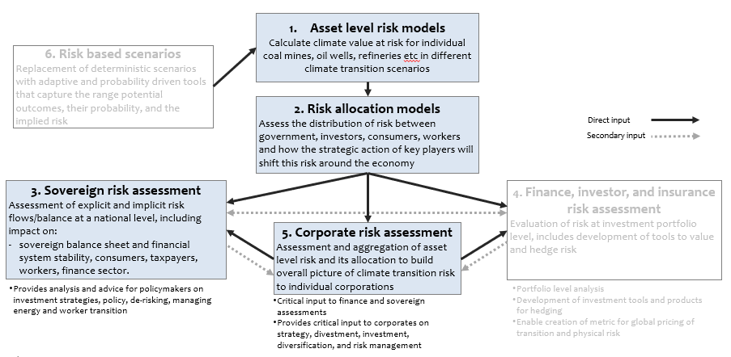
Source: CPI (2019)
CPI focused its analysis on the export sectors most exposed to a global transition and the major sources of domestic emissions:
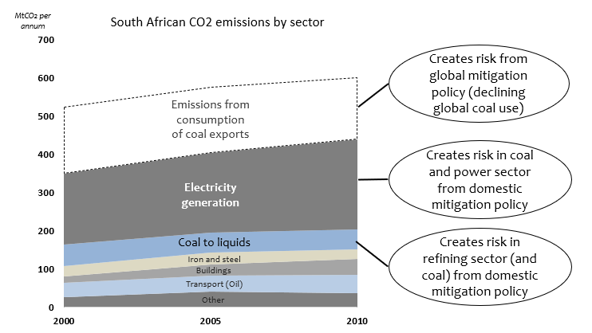
Source: CPI (2019)
In addition, CPI paid particular attention up front to the links between the public finances and different parts of an economy to better understand the transition risks transmission channels and engaged closely with a wide range of stakeholders to ensure that this analysis is accurate as well as to improve the chances that there will be buy-in to results. In the context of South Africa, CPI looked in detail at some of the publicly owned financial institutions including the DBSA, which plays a key role in the economy by lending to and owning listed securities.

Results from the South Africa analysis
- The climate transition risk is very important: CPI calculated that between 2015 and 2035 the value at risk would be around 125 billion dollars - 5 times the size of the coronavirus recovery package announced by the government.
- Much of South Africa’s climate transition risk is from factors out of their control such as thermal coal exports (i.e. international demand). Future prospects for thermal coal exports have already fallen sharply over the last five years.
- Domestic climate policy could add further risk for some assets, like the highly emission-intensive Secunda coal-to-liquids plant, that are already exposed to external transition risk.
- If CPI had considered only ownership, taxes, regulation and contracts, less than 20% of the risk lies with the public finances. But companies and financial institutions will take action to mitigate their exposure to transition risk, including coal miners seeking to sell more to the domestic market. Coal miners may seek to renegotiate rail and port contracts as export demand falls, but that action could seriously undermine the economic viability of the main railway line by the 2030’s.
- CPI considered the impact on the financial standing of key corporates, municipalities and financial institutions and their ability to mitigate and withstand residual climate transition risk
  - CPI considered the overall value at risk in the context of the company's current market value. The good news is that CPI found that most of the large companies would face significant downside risk, but perhaps not so large as to cause anyone to default on debts or go bankrupt. The bad news is that this is a static picture, which does not take into account companies selling assets for example. In the South African mining industry, large internationally diversified investment grade mining companies who would be easily able to bear transition risk and pay for shutdown costs have been selling to local players who are often undiversified and backed by a South African public funds through DFIs. If the picture stays as it is, then the impact might be manageable. If much of that risk is pushed on to actors who are unable to bear it, then the likelihood of companies going into financial distress will rise significantly and the chances of companies seeking bailouts or governments having to spend on mental distress goes up significantly
  - From publicly available information, it seemed that public financial institutions had more climate transition risk exposure than private financial institutions
- After accounting for risk transfers, the South Africa national government may in fact end up bearing more than half of the total risk. A significant amount of the domestic South African organizations would either face financial distress or in the case of some of the state-owned enterprises perhaps lose their investment grade credit ratings and become more reliant on national government guarantees in order to issue debt. From the big picture of twenty billion of risk explicitly falling on the government, CPI identified that when going through the whole analysis probably more than half of the risk in reality was likely to fall on the government.
- By weakening the public finances, climate transition risk could – if not monitored and managed - hurt South African long-term growth prospects and development outcomes. Risk on government in some respects is going to lead to higher public debt and South Africa might lose investment grade credit rating, which in itself could cause a whole series of secondary consequences that are not included in these numbers. South Africa is going to have even less financial flexibility to make the investments needed for the transition and could become more reliant on the DFIs
On the basis of that analysis, CPI proposed a series of recommendations and is exploring how to implement them with South African partners. Matthew highlighted among others, the recommendations regarding infrastructure projects in the pipeline, which would not be viable in a low-carbon economy.
Extending CPI’s analysis beyond South Africa
CPI posited that this type of analysis provides detailed information about who will be affected, when and by what drivers. This provides governments the ability to plan for targeted policy responses whether just transition planning for workers, financial regulatory actions like stress tests, changing capital requirements or even identifying upside opportunities.
CPI is working with AFD and a range of other partners to extend this type of analysis to other countries and to other investor, DFI and public policy applications.
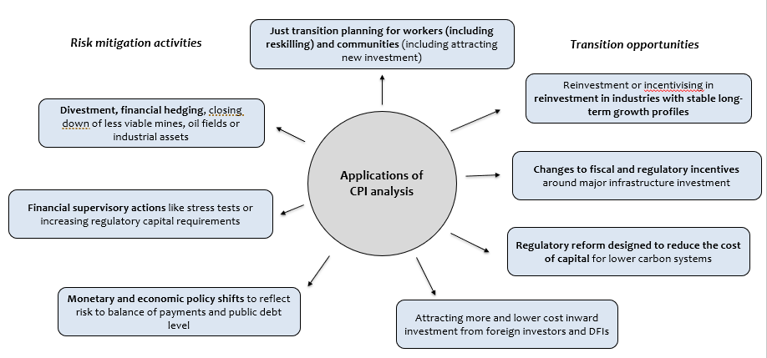

Discussants

Perspectives from the Development Bank of Southern Africa on outcomes of the report and developments that have followed its release
Libby Dreyer (DBSA) started her response by recalling the current context: an unprecedented global financial crisis, which has been triggered by a health pain pandemic. She highlighted that scientific evidence tells us that climate change impacts are likely to be far worse and more extreme. She also indicated that as development finance practitioners gain from this experience they need to match financing with the with the needs of both the market and society to understand the interplay between both local and global interventions and financing. Long-term and resilience-based risk approaches are absolutely essential for companies and financial institutions. DFIs only succeed through multi-stakeholder and partnership-based interventions.

In 2019 the DBSA board considered in detail the CPI report and the implications of transition risk for both the country and the Development Bank. In assessing this report DBSA board directed its team to look at the implications for the DBSA energy sector decision making, in respect of:
- Strategic positioning of the DBSA as a responsible energy sector investor on the African continent;
- Implications of transition risk and the threat of stranded assets in the DBSA energy sector investment portfolio;
- Adoption of appropriate measures, to enable the bank to identify, quantify and mitigate transition risk;
- Informing the role the Bank plays in contributing and adding impetus to efforts to support a just transition to a low carbon economy.

The findings presented today are not yet final. Nevertheless, the DBSA’s response offered an outlook of some initial proposals currently under discussion:

- Positioning DBSA as a responsible energy sector investors on the continent.
DBSA focused firstly on its role and responsibilities as an infrastructure development finance institution. DBSA has been guided by the development policies and goals that impact its work as an institution. Importantly these development policies and goals underpin and drive DBSA’s commitment to strengthen and enhance its responsibility to invest in interventions which support the transition to a low-carbon economy. In this regard, DBSA set particular targets to ensure that its financing aligns to that commitment.

- DBSA energy portfolio & vulnerability to climate change related risks
DBSA considered the total vulnerability of DBSA energy portfolio to climate change related risks and assessed DBSA energy investment portfolio on the basis of the Task Force on Climate related Financial Disclosures (TCFD) framework:
- Strategic risk: Energy portfolio exposure to carbon intensive assets that may misalign with DBSA's mandate and the political agenda;
- Business risk: Vulnerability to low carbon alternative technologies, and new policies, regulations and incentives that could replace higher carbon assets;
- Financial risk: Exposure of energy portfolio to changes in energy prices, carbon pricing and divestment campaigns;
- Operational risk: Vulnerability of energy portfolio assets to climate change.

The impact of the low carbon transition on DBSA’s business was assessed against three possible scenarios drawing on the International Energy Agency’s (IEA) World Energy Outlook (WEO) 2019 report:
- Stated Policies Scenario (STEPS): Maps where national climate related commitments & policies to meet Paris Agreement objectives for energy system by 2040;
- Africa Scenario (AC): outlines the Africa Union Agenda 2063 vision to achieve a sustainable future for next 50 years;
- Sustainable Development Scenario (SDS): Designs a developed pathway to maintain global temperature risk rise to below 2°C by 2050 & changes to global energy system to achieve this goal.

DBSA then mapped DBSA energy sector portfolio exposure (by country, technology & term) to high risk climate assets against the three identified scenarios over 5-15 years to understand what the three scenarios meant for DBSA: how quickly it needed to address transition risk and where exactly the stress lies within DBSA portfolio.

On the basis of this assessment DBSA looked at possible future energy and a possible future energy opportunity landscape:
- Identify opportunities to further commit to supporting the energy transition through sustainable finance;
- Suggest sustainable finance products to achieve DBSA Climate Policy Framework;
- Indicative energy sub sector investment targets proposed to achieve Africa Case Scenario for 30% & 50% of Investment Portfolio.

On that basis, DBSA started to unpack an energy investment proposal to address the threat of transition risk for its investment portfolio and this integrated energy investment framework proposes the construction of a climate aligned portfolio to lower the potential of transition risk relating to stranded assets through:
- The redeployment of historically concentrated DBSA capital to lower carbon solutions
- The uptake of investment in a larger range of generation technologies
- Scaling up of sustainable investment projects to support bankability
- Unlocking focused interventions to support the energy transition
- Pursing regional disbursement opportunities within identified resource locations including:
  - Strengthening DBSA footprint in markets where Bank currently invested
  - New target markets for deployment of existing DBSA service offerings for energy sub sector

Libby Dreyer shared thinking currently under discussion at the DBSA concerning the Investment Strategy Prioritization that could include:
- Phased redeployment of capital based on the current disbursements profile & matching DBSA responses to changing low-carbon scenarios;
- Continued role for project preparation and planning in supporting the development of low carbon solutions and in bringing projects which meet DBSA’s criteria to bankability;
- Strengthening interventions to support climate aligned product development including the uptake of green & sustainability bonds;
- The business to aggressively pursue the expansion of development and investment partnerships and institutional arrangements to enhance investment in low carbon opportunities;
- Ongoing and consistent monitoring of the DBSA investment portfolio to determine potential increase or decrease in transition risk (stranded asset exposure) as DBSA responds to the changing & address any interventions in response to the shifting risk profile;
- Short, medium & long term investment targets to strengthen the climate aligned portfolio.

Within this process, Libby Dreyer presented how DBSA is seeking to ensure that energy investment recommendations align with Responsible Investment Principles:
- Enables DBSA to effectively incorporate environmental, social and governance (ESG) factors in its investment decision making;
- Achieves superior returns through an effective ESG aligned portfolio which at the same time bears reduced financial and stranded asset risk;
- Reduces risk related to declining value of high carbon assets.

Libby Dreyer highlighted that DBSA approach to address transition risk is fundamentally looking at supporting a ‘Just transition’ within South Africa and will focus on four key areas:
Investment strategy
- Assess portfolio exposure to the social dimension of the transition –55% of DBSA energy portfolio exposed to the risk of job losses -maximise job creation and local economic development potential arising from renewables expansion;
- Dialogue with stakeholders –focus on priority interventions such as those through the National Planning Commission;
- Integration into investment strategy –uptake of social investment opportunities such as investments in biomass projects in areas where coal plants are being decommissioned / local agriculture investment opportunities.

Corporate engagement
- Engage with the management of loan recipients to ensure strong performance on labour & community practices;
- Work with loan recipients to develop opportunities to mitigate socio-economic impacts;
- Partner with large employers to develop financial products and services that support pre and post-layoff planning and assistance.

Capital allocation
- Incorporate economic development in communities negatively affected by the low carbon transition – ramp up infrastructure investment in social & municipal infrastructure;
- Explore new investment products and services that result in positive social impacts;
- Link investments in products and services to business models that promote local job creation and training.

Policy advocacy and partnerships
- Engage with governments to drive policy outcomes;
- Advocate for governance improvements to ensure predictability and stability for potential investors in Africa.
Libby Dreyer finished with a few high-level key findings from DBSA’s uptake of CPI’s work and the resulting strategic orientations under consideration:
- DBSA Strategic alignment to development policy frameworks globally & nationally
- Climate risk within the DBSA energy portfolio to be managed
- Clear role for DBSA identified as a responsible energy sector investor on the continent
- High level financing opportunities identified within energy sub sectors aligned to a low carbon transition
- Need for further project preparation and business development to maximise the role that the Bank can play in supporting the transition to a low carbon economy
- Work to be undertaken at operational level in bedding down investment approach within DBSA operations

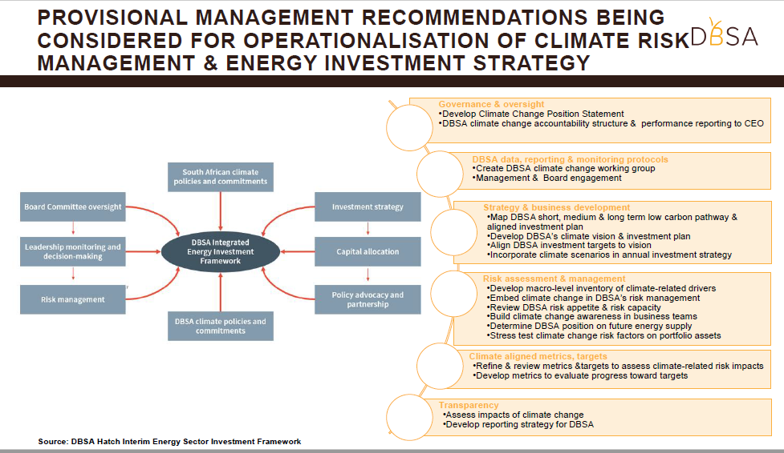

Perspectives from the French Development Agency on the impacts of the study on AFD’s operations in South Africa, and presentation of broader reflections and developments on the management of transition risks at the international level

Carl Bernadac (AFD – South Africa Office) highlighted two key elements to really resonate into domestic policy dialogue:
- The quality of the study
- Partnering with DBSA

He then briefly presented South Africa-related follow-ups to the study:
- “Thinking together” South African DFI’s: AFD engaged with another DFI in South Africa as well: the Industrial Development Corporation (IDC);
- Climate Risks and Financial Stability: one of the next steps is engaging and partnering with central banks and regulators to monitor climate related financial risks;
- Stimulus and recovery package / COVID-19: while it will not be easy to put the issue of transition risks on the agenda it will be important, otherwise it may lead to future economic loss which will translate into job losses and social impacts.

Laurent Bergadaa (AFD) then presented Non-South Africa-related follow-ups to the study:
- Future AFD-CPI collaborations and studies in other countries: China, India, Indonesia, Morocco and Columbia
- Extension and improving the methodology: other industrial sectors, land-use, stronger focus on just transition, links to macro-models
- Possible application to physical risks
- Wider range of partners and greater outreach: this has to be a collaborative effort amongst financial institutions first and foremost but also think-tanks governments and even civil society

Q&A
- Ian Cochran (Secretariat): What challenges might DBSA encounter in terms of taking this risk analysis which will of course have broader economic and social challenges and finding a way to link that again with the challenges posed by acting on climate action?

Libby Dreyer (DBSA) answered that firstly, the difficulty relates to undertaking any change process within any institution. Institutions do not like change, they have established practices, procedures and organizational policies. Facing this requires finding the right leaders to drive that change and then the right partners to drive new business opportunities and new approaches.

Secondly, this relates to some practical things: finding the right projects which one can invest in, which support a low-carbon transition, ensuring the bank ability to finance those projects. Low-carbon solutions are much smaller and involve a range of parties. The challenge for an institution like DBSA is to understand the different financing dynamics and how one prepares and gets those projects to bankability.

Thirdly, in a coal-based economy like South Africa the transition implications are very much people implications and they very much impact jobs, livelihoods and established economic practices. Ensuring a just transition involves looking at business practice and ensuring that opportunities are real to move from one world to the other.

- Ian Cochran (Secretariat): What challenges has CPI faced in socializing one of the most surprising findings of the study that it is actually not the direct carbon pricing that might pose the most significant or some of the challenging risks?

Matthew Huxham (CPI) answered that it has not been that difficult, but it depends on the groups that you are talking to. Most of the many companies and investors within South Africa that CPI spoke to about this did not really believe that the transition to a 2 degrees world was a realistic possibility. There is a carbon tax at a relatively modest level being introduced in South Africa, and they did not really identify that major changes could be driven by carbon prices.

He indicated that it has been easier to get people to buy in to the reasons why renewable energy costs have come down so far and are now competing coal in most places in the world. And this is driven in most places not by carbon prices but by support for renewable energy, which is driving economies of scale and technological improvements. Clearly, the carbon price has been a much more relevant driver in Europe in the power sector and may yet be in other industries such as steel production and cement production where the cost of low-carbon alternative is so much higher currently, but in power at least it does not even really enter the conversation.

The carbon price based and general equilibrium model approaches that many of the most forward-looking central banks are considering now for their stress tests will produce some interesting results but we know now that the carbon price is probably not likely to be the driver of the transition in the oil sector. There are quite a wide variety of different changes which are driving the climate transition.

Webinar Materials
- Report: Understanding the impact of a low carbon transition on South Africa, CPI, 2019
- Case study: AFD’s Initiative on Assessing and Managing Physical Climate Risks
- Recording: https://youtu.be/gEyKBiMNpvc
Please do not share this link beyond your institution.

To learn more in this case study: AFD’s Initiative on Assessing and Managing Physical Climate Risks

